**BANKING APPLICATION**

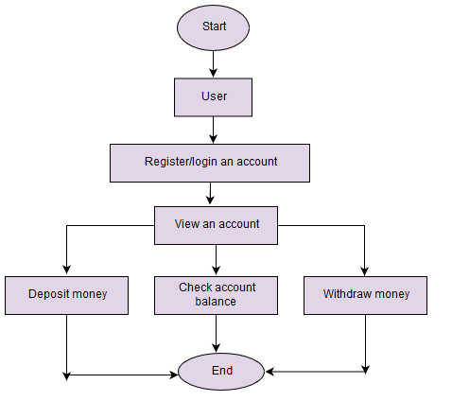

**Register:**

As a Customer, I want to register for the banking application by entering required details, so that I can login after registration.

As a Customer, I want to receive an email after registration, so that I can have an idea about registration status.

ACCEPTANCE CRITERIA:

* The registration page should include fields for the user to input their personal information such as full name, email address, password, and any other required details.
* All required fields must be marked clearly, and the user should not be able to proceed with registration until all required fields are filled out.
* Password requirements should be clearly communicated to the user (e.g., minimum length, special characters required).

**Login:**

As a customer, I want to log in to my banking account using my username and password, so that I can access the banking application.

As a customer, I want the login process to be secure, requiring multi-factor authentication, so that my personal information and account data are protected from unauthorized access and potential cyber threats.

As a customer, I want to reset my password if I forget it, receiving a temporary password via email or SMS, so that I’ll always have access to my account.

ACCEPTANCE CRITERIA:

* The login page should include input fields for the user to enter their username/email and password.
* If the user enters incorrect credentials, an error message should be displayed indicating that the login attempt was unsuccessful
* The application should have a mechanism in place to handle forgotten passwords, such as a "Forgot Password" link that allows users to reset their password via email or SMS.

**View an account/ account management:**

As a customer, I want to view my account details, balance and recent transactions, so that I can monitor my financial activities, track my expense and security of my account information.

ACCEPTANCE CRITERIA:

* Users should be able to view comprehensive details of their accounts, including account type, account number, current balance, and account status.
* Users should have the ability to update their personal information such as name, address, email, and phone number.
* Users should have access to their transaction history, allowing them to view detailed information about past transactions, including dates, amounts, transaction types, and transaction statuses.

**Deposit Money:**

As a customer, I want to deposit money into my checking account using the mobile banking app, I can conveniently and securely add funds to my account without the need to visit a physical bank branch.

As a customer, I want to transfer funds from another bank account into my account via the banking app, so that I can easily and securely move money between accounts without the need for visiting a physical bank branch.

ACCEPTANCE CRITERIA:

* After initiating a deposit, users should receive immediate confirmation of the deposit request along with any relevant details such as deposit amount and transaction reference number.
* The system should validate all required fields and ensure that users provide accurate and complete information before proceeding with the deposit.

**Check account balance:**

As a customer, I want to check my account balance quickly and easily through the mobile banking app, so that I can stay informed about my financial status at any time and from anywhere.

ACCEPTANCE CRITERIA:

* Upon checking account balance, the system should display the current balance of the user's account.
* Common issues such as network errors or temporary system outages should be communicated to the user with instructions on how to proceed.

**Withdraw money:**

As a customer, I want to withdraw cash from my checking account at an ATM using my debit card, so that I can access my funds conveniently and securely whenever I need cash, regardless of the time or location.

As a customer, I want to receive immediate confirmation and acknowledgment of my withdrawal transaction, so that so that I can know that my request has been successfully processed and my account balance accurately reflects the withdrawal.

As a customer, I want to view my withdrawal history and details, including dates, amounts, and transaction types, so that I can track my spending patterns and security of my account activity.

ACCEPTANCE CRITERIA:

* After initiating a withdrawal, users should receive immediate confirmation of the withdrawal request along with any relevant details such as withdrawal amount and transaction reference number.
* Users should receive notifications (e.g., email or push notifications) confirming the success of their withdrawal transaction.
* The notification should include details of the withdrawal such as the withdrawn amount and the account from which it was debited.